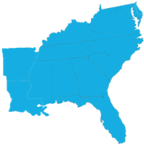
Southeastern Composers’ League
SCL 2024 Student Composition Contest Application Form

This form must be submitted by each candidate.
Deadline for submissions is February 15, 2024.
Send this completed application page
With your pdf score and mp3 recording as attachments to this link:
mailto:lbarnes@transy.edu?subject=SCL composition contest.
Only applicants currently studying with an SCL member, or who are SCL student members in good standing are eligible.
Title of composition _______________________________________________
Instrumentation (voice is an instrument) ______________________________
Composer_______________________________________________________
Date of composition (month/year) _______________________

___ I certify that I am a student member of the SCL
OR
___ I certify that my composition teacher is a member of the SCL
OR
___ I am joining the SCL with this application. Dues are $25 and are being paid.

Student name (print)__________________________ SCL member yes__ no__
Student signature ____________________________

Faculty name _______________________________ SCL member yes __ no__
Faculty signature ____________________________

Founded in 1950, the Southeastern Composers League is an association of art music composers and scholars located throughout the Southeastern United States. It is one of the oldest organizations of its kind in America.
The League is comprised of composers from Alabama, Arkansas, Delaware, District of Columbia, Florida, Georgia, Kentucky, Louisiana, Maryland, Mississippi, North Carolina, South Carolina, Tennessee, Virginia and West Virginia.

